Bruno Nunes Vaz

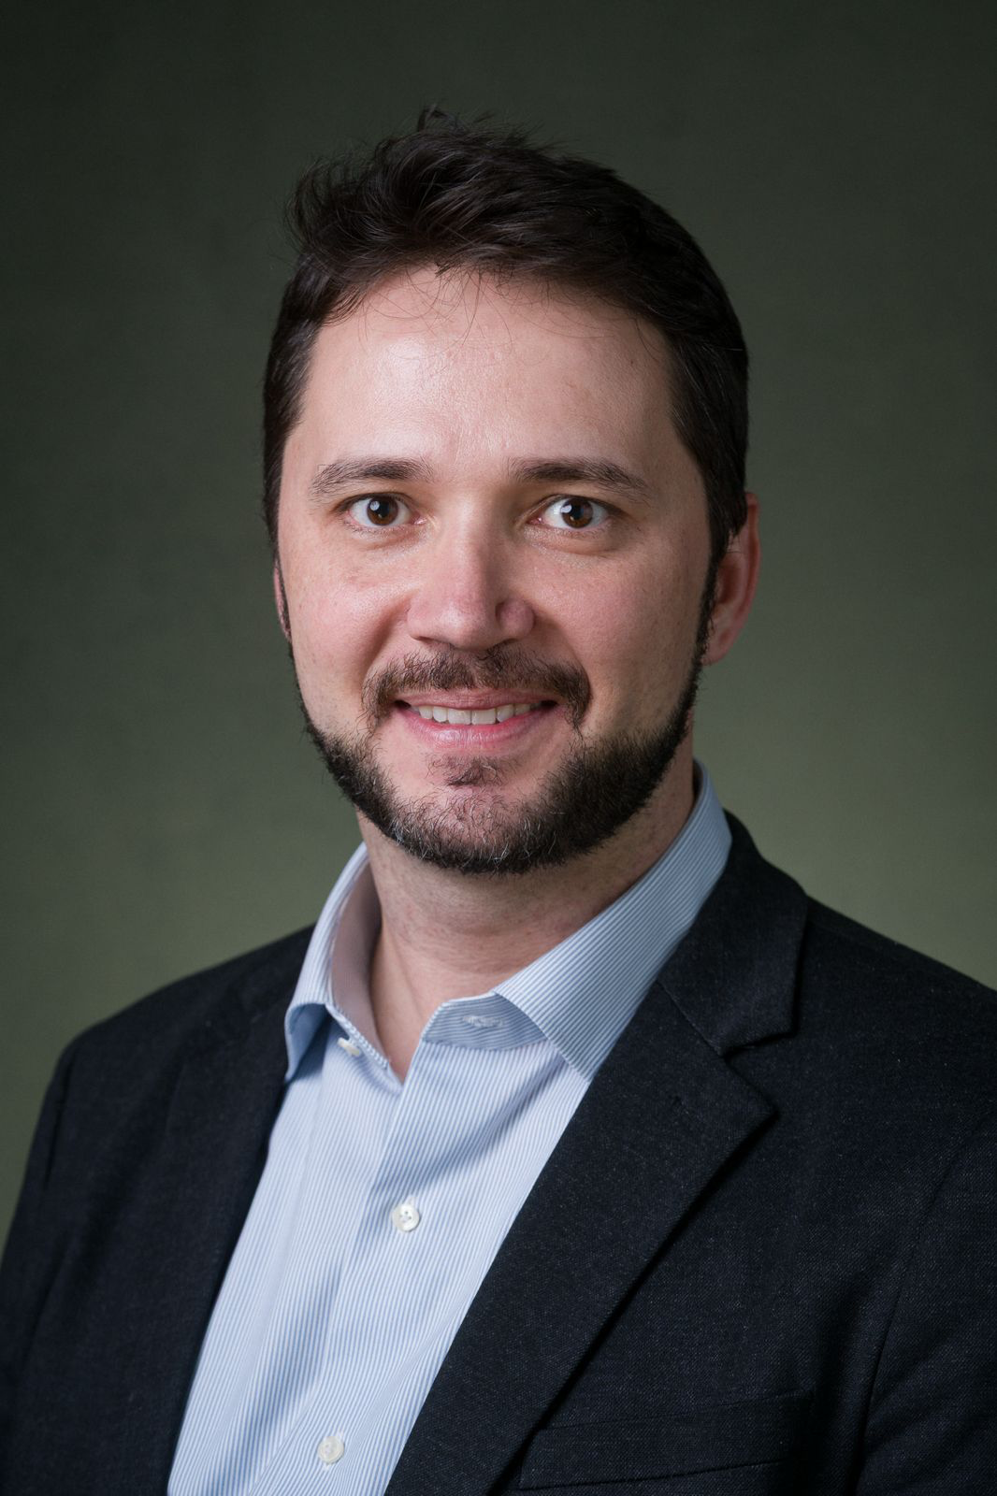

Space entrepreneur and PhD candidate in Space Sciences and Technologies at the Aeronautics Institute of Technology (ITA) in Brazil, currently a Visiting Researcher at the Politecnico di Milano (PoliMi). His doctoral research examines the dynamic governance of emerging space ecosystems by integrating Stafford Beer’s Viable System Model (VSM) with organizational process philosophy, shifting the traditional analytical focus from static structures to the emergence of dynamic networks.

